C4 DESIGN DOCUMENT
DIVYANSH GUPTA
INFORMATION TECHNOLOGY
IFT 593: APPLIED PROJECT
PROF. DINESH STHAPIT
JANUARY 24TH, 2025

C4 Model for RAG-Enhanced Audio Dubbing System

Level 1: System Context Diagram
Purpose: Provides a high-level overview of the system, showing how it interacts with external entities.
System: RAG-Enhanced Multimodal Translation System
External Entities:
- Content Providers: Upload source multimodal data (audio, text, etc.) for translation.
- End Users: Consume translated multimodal content in their native language.
- GPT-4o API: Provides transcription, translation, and synthesis capabilities.
- Knowledge Base: Stores domain-specific terms, glossaries, and contextual information for retrieval.
Interactions:
- Content providers upload multimodal files (e.g., audio, video) and specify target languages.
- The system processes data through transcription, translation, and synthesis using the GPT-4o API.
- The system retrieves contextual data from the Knowledge Base to enhance translation accuracy.
- The system delivers translated and synthesized multimodal outputs to end users.
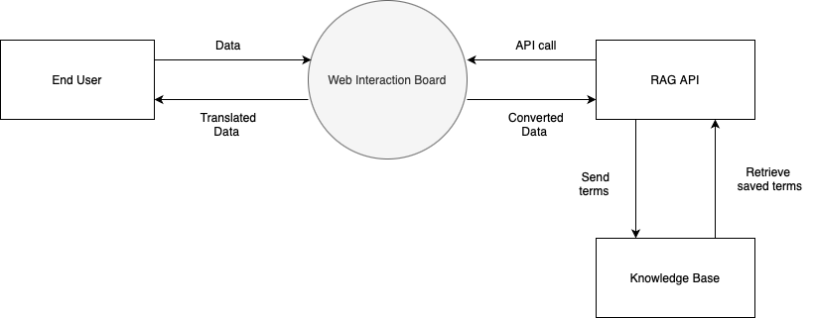
Figure 1: C1 System Context Diagram

Level 2: Container Diagram
Purpose: Shows the major components ("containers") within the system and their interactions.
Containers:
- Web Application:
  - Description: User-facing interface for uploading audio and managing requests.
  - Technologies: ReactJS, Flask/Django.
  - Responsibilities: Collects user inputs, sends requests to backend, and displays results.
- GPT-4o Integration Layer:
  - Description: Interfaces with OpenAI’s GPT-4o API.
  - Technologies: HTTP API calls (via requests library).
  - Responsibilities: Sends audio inputs, retrieves transcriptions, translations, and dubbed audio outputs.
- Knowledge Base:
  - Description: Stores glossaries, domain-specific terms, and prompts.
  - Technologies: SQLite, local file storage.
  - Responsibilities: Provides contextual prompts to enhance GPT-4o outputs.
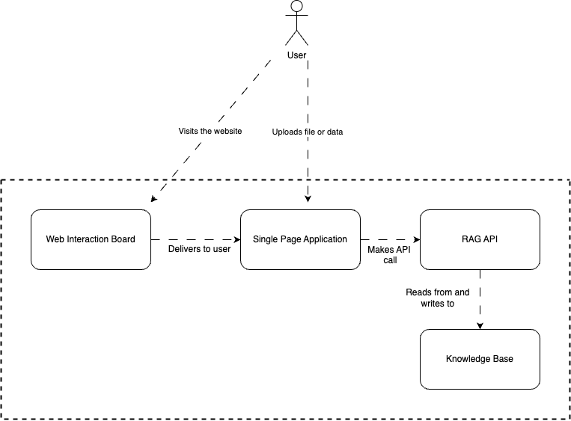
Figure 2 : C2 Container Diagram

Level 3: Component Diagram
Purpose: Explores the internal structure of key containers, focusing on their components and relationships.
Components:
- Web Application:
  - Frontend: Collects user inputs, displays results (ReactJS).
  - Uploader Module: Handles audio file uploads.
  - Result Viewer: Displays dubbed audio outputs and transcripts.
- Knowledge Base:
  - Glossary Manager: Maintains terms to be retained in their original language.
  - Context Retriever: Retrieves relevant context from local data storage.
- GPT-4o Integration Layer:
  - API Client: Manages requests to OpenAI’s API.
  - Response Parser: Extracts and formats results (transcriptions, dubbed audio).
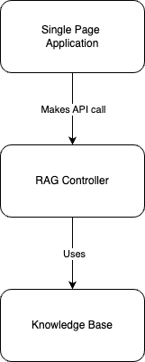
Figure 3: C3 Container Diagram

Level 4: Code/Implementation Details
Purpose: Details the implementation of a specific component within the system.
Component: Transcription Module (Processing Engine)
- Key Functions:
  - process_audio_with_gpt_4o(base64_audio, modalities, prompt): Sends audio to GPT-4o API for transcription.
  - retrieve_glossary_terms(language_pair): Fetches relevant glossary terms for source and target languages.
  - format_transcription_response(response): Cleans and structures transcription results.
Component: Evaluation Module (Processing Engine)
- Key Functions:
  - calculate_bleu_score(reference, candidate): Evaluates translation accuracy using BLEU.
  - calculate_rouge_score(reference, candidate): Benchmarks translation quality using ROUGE.
  - optimize_prompts(scores, parameters): Refines prompting strategies to improve scores.

